**Integrating Jenkins with Maven**

1. Fork GitHub Repo - <https://github.com/chaitanyagaajula/simple-java-maven-app>

2.Install java and Maven

yum install java

yum install maven

5.Create a folder on Jenkins Server and pull the code from Git repository

root@ip-172-31-85-119 JenkinsProject]# pwd

/root/JenkinsProject

yum install git

git clone https://github.com/chaitanyagaajula/simple-java-maven-app.git

[root@ip-172-31-85-119 JenkinsProject]# ls -ld simple-java-maven-app/

drwxr-xr-x 5 root root 4096 May 3 16:11 simple-java-maven-app/

6.Create a new pipeline project and configure SCM details as below to poll repository every minute and run the script which is defined in the Jenkinsfile. (Note:Test by committing a new file in GitHub and also using GitHub hook trigger )

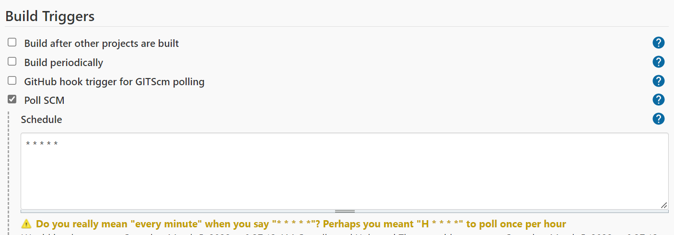

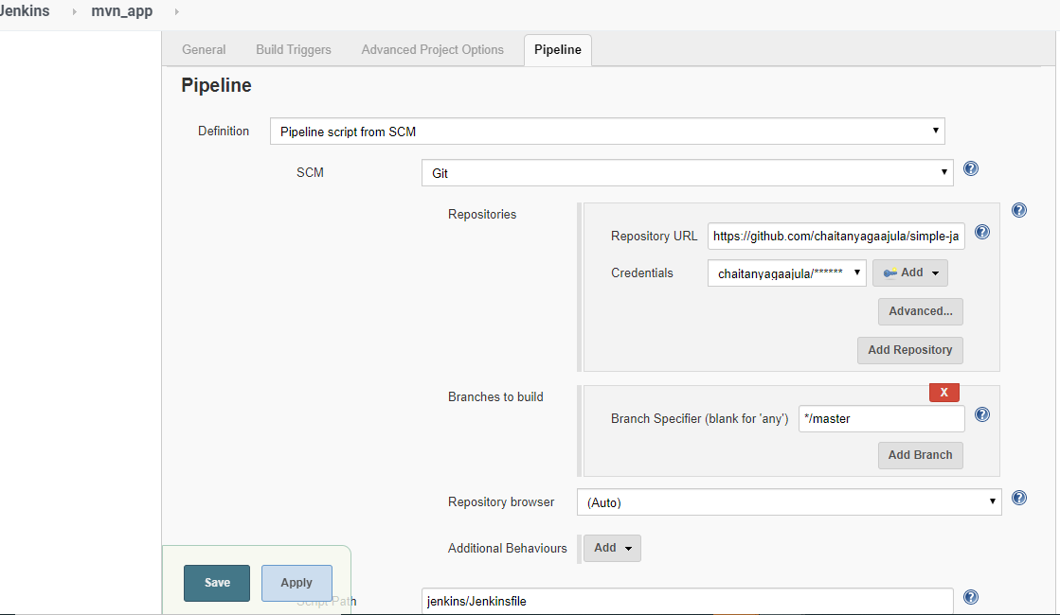

1. Observe the build , test and delivery stages get initiated automatically after a minute .In the console Output of the last stage “ Deliver” we can see a Jar has been build using maven and displays Hello World

